BSCH – MD- Assignment 03

Treasure Hunt App

**Author: Sarah Brennan**

**Student Number: 2962279**

# Implementation of Functionality asked

Record location: In both of the Activities there is a method called getGPS(). This checks the GPS sensor and gets the longitude and latitude of where the player is. The MainActivity has 2 textviews that then print out the longitude and latitude of the player.

Check against the Treasure Hunt location: In TreasureActivity, there is a textview that prints out the distance from where the player is to the Treasure Hunt location in kilometres. This is updated to begin with when the user clicks on the treasure hunt they want to start. It also updates when the button “Check distance from Treasure” is clicked.

Scoring/winning formula for game: There is a score textview in TreasureActivity. Every time the player wants a new clue, the score goes down by one point. The highest score the player can win by is the total amount of clues, the least amount the player can get is 1.

Placeholders for clues: In TreasureActivity, there is a textview that updates with the first clue once a trasuer hunt is selected. The player can then get more clues by clicking the button, however, their score will then decrease.

Start and Stop tracker: In MainActivity, there is a switch that allows the player to track/untrack their location. To play the game and go to TreasureActivity, the player must have tracking on.

Explain how it works: In the MainActivity there is a textview that explains how the game works.

Timer: There is a timer on the MainActivity. This starts when the tracker is started, and stops if the player chooses to stop the tracker. The tracker also stops when the player wins the game.

Innovation: within the emulator, there is the ability to set the location for where the phone is “located”. To do this, click on the three dots on the side of the phone, under Location there is the ability to search for locations and save the points. These can then be set. This helped to test the application and make sure that the correct information was being outputted to the player. Below are screenshots of how to do this:

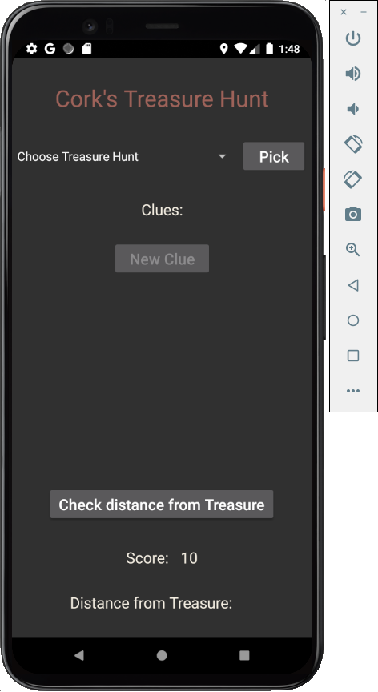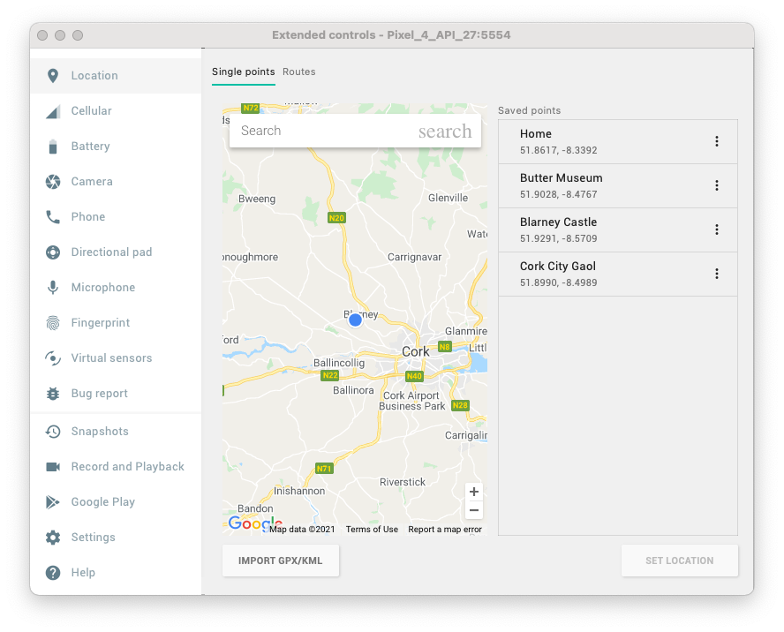

# Presentation and Style

Below are screenshots of both Activities made. The palette is dark to go with a pirate theme.

## Design of MainActivity:

The Current Longitude and Latitude textviews and timer update when the Tracker switch is turned on, which can be seen in the right screenshot above.

## Design of TreasureActivity:

Then the player picks a treasure hunt from the spinner and clicks the Pick button, the spinner and Pick button will be disabled. The New Clue button then becomes enabled and allows the player to get more clues if they want, but the score reduces. The distance from treasure textview will also update with the distance in kilometres.

# Errors Encountered

When I first tried to get the application to work with GPS sensors, because I was using Goggle Play Services, I could not get the application to work on the emulator I had set up. The design would show up but as soon as I tried to start the tracking of the current location I got an error stating that the location was null. This was because the emulator I was using did not have Goggle Play Services enabled. To get around this, I downloaded a new emulator that allowed the app to work. Below is a screenshot of an emulator with and without Google Play Services, can be known by the play icon that can be seen:

